Q1. The following table is from a study that has a binary response (Y=1 or 0), two treatment groups (T=’A’ or ‘B’), and a stratification variable (X=’+’ or ‘-‘). The table entries provide ([number of cases with Y=1]/[total number of cases]) for each of the 4 cells formed by the level combinations of the treatment (T) and the factor (X). Row and column totals are also presented. The response rates for the two treatment group at each level of X can be found on the last two columns of the table. For this data set, use the **Cochran-Mantel-Haenszel (CMH)** test to compare the response rates between the two groups. Discuss your findings. Note. This is part of Homework 5.2 of [T2].

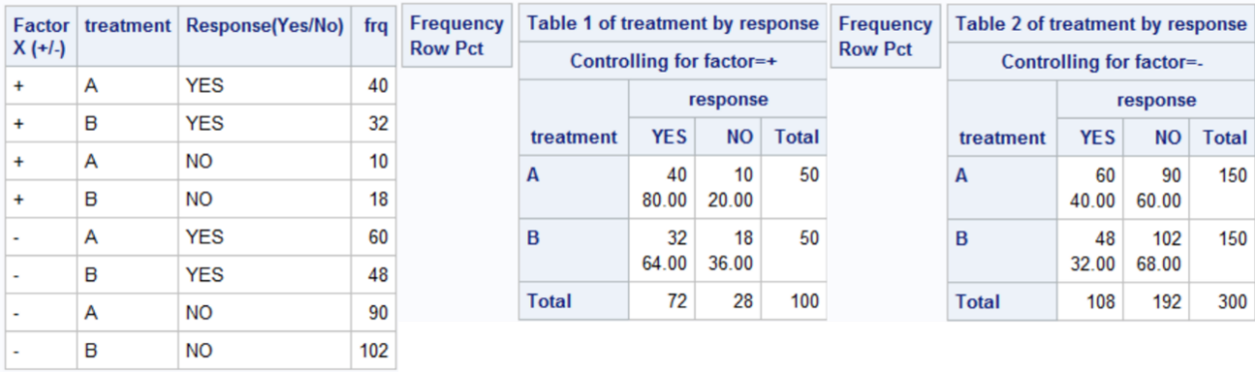

**CMH test statistic:**

Value=4.4586, Prob=0.0347

With p-value = 0.0347 < 0.05, we reject H0 at level α=0.05, and conclude:

* **Nonzero Correlation**: there is significantly nonzero correlation between treatment and response when controlling for the stratification factor (Factor X).
* **Row Mean Scores Differ**: between the rows (=treatment groups A and B), there is a difference in the mean response scores (proportion of positive response) after adjusting for the effect of the Factor X.
* **General Association**: there is a general association between treatment and response after adjusting for the effect of Factor X.

**Odds Ratios and Relative Risks:**

* **Mantel-Haenszel Odds Ratio by MH =**1.5682. After adjusting for Factor X, the odds of a "Yes" response are about 56.82% higher in treatment A than in treatment B (95% CI is greater than 1, supporting the statement)
* **Relative Risk (Column 1) by MH =** 1.25. There is a 25% higher Pro(response="Yes") in Treatment A compared to Treatment B, after controlling for Factor X. The 95% CI does not include ‘1’ supporting the statement.
* **Relative Risk (Column 2) by MH =** 0.8333. The likelihood of a "YES" response in Treatment B is 16.67% lower than in Treatment A, when adjusting for Factor X. The 95% CI < 1, supporting the statement.

**Breslow-Day Test** **Homogeneity of Odds Ratios across the strata:**

This is to test whether there is a consistent difference in the odds of a positive response between treatments A and B across the presence or absence (+/-) of Factor X, using CMH test. With a p-value of 0.3726, there is not enough evidence to reject the homogeneity of the odds ratios across the strata. Thus, the treatment effect is consistent across the different levels of Factor X.

**Conclusion:**

The results from the CMH test indicate that there is a statistically significant association between treatment and response, controlling for Factor X. The effect of treatment on the response seems to be consistent across the levels of the stratification factor. Treatment **A** is associated with higher odds and risk of a positive response compared to Treatment B.

Q2. The next table is similar to that in Q1, but the design is no longer a balanced design; i.e., for each level of X, the sample sizes for the two groups are not the same. Repeat the analysis in Q1 for this data set. Note that the response rates here are similar to that in Q1.

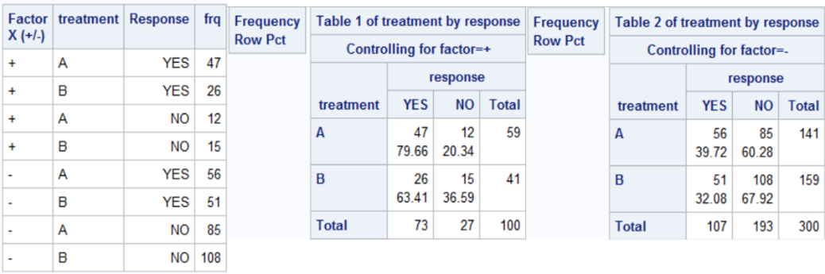

**CMH test statistic:**

Value=4.2201, Prob=0.0399

With p-value = 0.0399 < 0.05, we reject H0 at level α=0.05, and conclude:

* **Nonzero Correlation**: there is significantly nonzero correlation between treatment and response when controlling for the stratification factor (Factor X).
* **Row Mean Scores Differ**: between the rows (=treatment groups A and B), there is a difference in the mean response scores (proportion of positive response) after adjusting for the effect of the Factor X.
* **General Association**: there is a general association between treatment and response after adjusting for the effect of Factor X.

**Odds Ratios and Relative Risks:**

* **Mantel-Haenszel Odds Ratio by MH =**1.5487. After adjusting for Factor X, the odds of a "Yes" response are about 54.87% higher in treatment A than in treatment B (95% CI is greater than 1, supporting the statement)
* **Relative Risk (Column 1) by MH =** 1.2452. There is a 24.52% higher Pro(response="Yes") in Treatment A compared to Treatment B, after controlling for Factor X. The 95% CI does not include ‘1’ supporting the statement.
* **Relative Risk (Column 2) by MH =** 0.8383. The likelihood of a "YES" response in Treatment B is 16.17% lower than in Treatment A, when adjusting for Factor X. The 95% CI < 1, supporting the statement.

**Breslow-Day Test** **Homogeneity of Odds Ratios across the strata:**

This is to test whether there is a consistent difference in the odds of a positive response between treatments A and B across the presence or absence (+/-) of Factor X, using CMH test. With a p-value of 0.3509, there is not enough evidence to reject the homogeneity of the odds ratios across the strata. Thus, the treatment effect is consistent across the different levels of Factor X.

**Conclusion:**

The results from the CMH test indicate that there is a statistically significant association between treatment and response, controlling for Factor X. The effect of treatment on the response seems to be consistent across the levels of the stratification factor. Treatment **A** is associated with higher odds and risk of a positive response compared to Treatment B.

Q3. Repeat Q2 with the following table. Note again the change in the sample size.

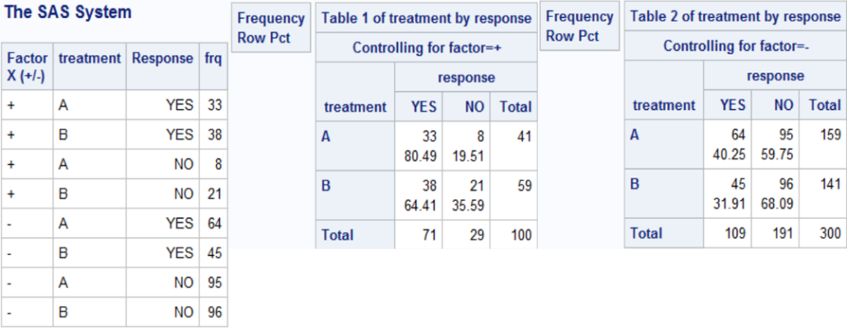

**CMH test statistic:**

Value=4.5771, Prob=0.0324

With p-value = 0.0324 < 0.05, we reject H0 at level α=0.05, and conclude:

* **Nonzero Correlation**: there is significantly nonzero correlation between treatment and response when controlling for the stratification factor (Factor X).
* **Row Mean Scores Differ**: between the rows (=treatment groups A and B), there is a difference in the mean response scores (proportion of positive response) after adjusting for the effect of the Factor X.
* **General Association**: there is a general association between treatment and response after adjusting for the effect of Factor X.

**Odds Ratios and Relative Risks:**

* **Mantel-Haenszel Odds Ratio by MH =**1.5853. After adjusting for Factor X, the odds of a "Yes" response are about 58.53% higher in treatment A than in treatment B (95% CI is greater than 1, supporting the statement)
* **Relative Risk (Column 1) by MH =** 1.2567. There is a 25.67% higher Pro(response="Yes") in Treatment A compared to Treatment B, after controlling for Factor X. The 95% CI does not include ‘1’ supporting the statement.
* **Relative Risk (Column 2) by MH =** 0.8299. The likelihood of a "YES" response in Treatment B is 17.01% lower than in Treatment A, when adjusting for Factor X. The 95% CI < 1, supporting the statement.

**Breslow-Day Test** **Homogeneity of Odds Ratios across the strata:**

This is to test whether there is a consistent difference in the odds of a positive response between treatments A and B across the presence or absence (+/-) of Factor X, using CMH test. With a p-value of 0.3889, there is not enough evidence to reject the homogeneity of the odds ratios across the strata. Thus, the treatment effect is consistent across the different levels of Factor X.

**Conclusion:**

The results from the CMH test indicate that there is a statistically significant association between treatment and response, controlling for Factor X. The effect of treatment on the response seems to be consistent across the levels of the stratification factor. Treatment **A** is associated with higher odds and risk of a positive response compared to Treatment B.

Imbalances in sample size may affect the precision of the estimated treatment effect. In an imbalanced design, larger strata will have a greater influence on the combined measure. In this Q3 data set with the imbalanced study design, the CMH analysis indicates that treatment A has about 58.53% higher effectiveness than treatment B across strata of factor X, and the Breslow-Day Test suggests this effect is consistent across the strata. However, without weighting strata in combined measure, the total response rates are similar with 48.5% for treatment A and 41.5% for treatment B.

4. Consider the data set (seizures.csv) for Example 11. Now include both *ln(age)* and *ln(baseline)* in the analysis. Select an appropriate model to study the effect of the treatment on the response profile. You may consider the generalized estimation equation (GEE) method introduced in class, but describe your final model, and the procedure that you used for model selection. Report your analysis results and conclusions on the comparisons of the treatment effects.

**Procedure:** For model selection in this study, I used Generalized Estimating Equations (GEE) and evaluated different covariance structures: independence, AR(1), exchangeable, and unstructured. The structure with the lowest Quasi-Information Criterion (QIC) was selected, which was **AR(1).**

Starting with a full model that included all main effects and potential interactions, I used a stepwise approach to remove non-significant terms, beginning with the highest-order interactions and closely observing changes in QICu values.

After assessing the models based on QICu, **Model 16** showed the lowest value and was thus determined to be the best fit. The final analysis was conducted using PROC GENMOD with this model. To examine the interaction effects in more detail, the **CONTRAST** statement in PROC GENMOD was used, along with the calculation of mlb (mean log baseline), to assist in interpreting the treatment effects in relation to the average baseline seizure count."

**Codes:**

*\* HW5-4: Generalized Estimation Equation;*

dm "output;clear;log;clear;odsresults;clear";

**options** ls=75 ps=2000 formdlim='*' nodate nonumber nocenter;

*\*\*\*\*\*\*\*\*\*\*\*\*\*\*\*\*\*\*\*\*\*\*\*\* I. data \*\*\*\*\*\*\*\*\*\*\*\*\*\*\*\*\*\*\*\*\*\*\*\*\*\*\*\*\*\*\*\*\*\*\*\*\*\*\*\*\*\*\*\*\*\**

*\* --- data set ---;*

**data** seizure;

infile 'C:\Users\jyang\OneDrive - Arizona State University\10 Classes_OneDrive\2024_STP598_Clinical Trials\Computing\Topic4\seizures.csv' dlm=',' firstobs=2;

input id trt age baseline visit1-visit4;

**run**;

**proc** **print**;

title 'HW5-4';

**run**;

*%macro* univfmt;

**data** uniseizure (keep=id trt age baseline visit cnt cell); %* only keep the useful variables in the final **data** set;

set seizure; %* create the **data** set using the previously created seizure **data** set;

baseline = baseline/4; %* adjust for the number of weeks for baseline;

*%do* i = **1** *%to* **4**; %* create two new variables, namely 'visit' and 'cnt';

visit = &i.; %* the ith visit;

cnt = visit&i.; %* the response at the ith visit;

cell = cat(trt,visit);%* Use CAT function to create a variable to indicate the (treatment, visit) combination;

output; %* create a record with the current variables in the **data** set;

*%end*;

**run**;

*%mend*;

%univfmt;

*\* --- data preparation for log-linear model---;*

**data** uniseizure;

set uniseizure;

log_age = log(age); */* Log-transform age */*

log_base = log(baseline); *Log-transform baseline, log(x);

logcnt=log(cnt+**1**); *obtain log(y) but avoid log(y=0);

**run**;

*\* --- sorting the data ---;*

**proc** **sort** data=uniseizure;

by trt visit;

**run**;

*\* --- visualization ---;*

*\* Visualize the data to check for linearity between log count and log baseline;*

ods graphics / attrpriority=none;

**proc** **sgplot** data=uniseizure;

styleattrs datalinepatterns=(solid);

**loess** y=logcnt x=log_base / group=cell; */* Replace cell with appropriate grouping variable if needed */*

**run**;

*\*\*\*\*\*\*\*\*\*\*\*\*\*\*\*\*\*\*\*\*\*\*\*\*\*\* II. Build model \*\*\*\*\*\*\*\*\*\*\*\*\*\*\*\*\*\*\*\*\*\*\*\*\*\*\*\*\*\*\*\*\*\*\*\*\*\*\*\**

*\* using PROC GENMOD with GEE for repeated measures*

*\* 1) independence structure, dispersion parameter, phi;*

**proc** **genmod** data=uniseizure;

class id trt visit;

**model** cnt = trt|visit log_age|trt|visit log_base|trt|visit / link=log type3 d=poisson scale=p; */*A|B|C = A B C AB BC CA ABC */*

repeated subject=id(trt) / type=indep within=visit modelse; */* Assuming independence */*

ods select GEEModPEst GEEFitCriteria;

ods output GEEModPEst=out1 GEEFitCriteria=out2;

**run**;

*\* From OUT1, we create a macro variable &phi to store the estimated sqrt(\phi);*

**proc** **sql**;

select estimate into :phi

from out1

where parm='Scale';

**quit**;

*\* Select an error structure with QIC: store QIC value for independent correlation structure;*

**proc** **sql**;

select value into :QICind

from out2

where criterion='QIC';

**quit**;

*\*\* 2) the AR(1) structure by keeping the same \phi-hat;*

**proc** **genmod** data=uniseizure;

class id trt visit;

**model** cnt= trt|visit log_age|trt|visit log_base|trt|visit /link=log type3 d=poisson scale=&phi. noscale;

repeated subject=id(trt) / type=ar(**1**) within=visit;

ods select GEEFitCriteria; *Only present this result;

ods output GEEFitCriteria=out2; *create output **data** sets to give the QIC;

title "Cov structure: AR(1)";

**run**;

**proc** **sql**;

select value into :QICar1

from out2

where criterion='QIC';

**quit**;

*\*\* 3) the exchangeable type covariance structure, i.e., compound symmetry;*

**proc** **genmod** data=uniseizure;

class id trt visit;

**model** cnt= trt|visit log_age|trt|visit log_base|trt|visit /link=log type3 d=poisson scale=&phi. noscale;

repeated subject=id(trt) / type=cs within=visit;

ods select GEEFitCriteria;

ods output GEEFitCriteria=out2;

title "Cov structure: Exchangeable";

**run**;

**proc** **sql**;

select value into :QICcs

from out2

where criterion='QIC';

**quit**;

*\*\* 4) The unstrcuted covariance, not working well;*

**proc** **genmod** data=uniseizure;

class id trt visit;

**model** cnt= trt|visit log_age|trt|visit log_base|trt|visit /link=log type3 d=poisson scale=&phi. noscale;

repeated subject=id(trt) / type=un within=visit;

title "Cov structure: Unstructured";

**run**;

title;

*\*\*\*\*\*\*\*\*\*\*\*\*\*\* III. Compare the three covariance structures \*\*\*\*\*\*\*\*\*\*\*\*\*\*\*\*\*\*\*\*\*\*\*\*\*\*\*\*\*\*\**

*\*\*\*\* AR(1) yields a slighly smaller QIC than CS;*

**data** _null_;

file **print**;

put "Indep.: &QICind"; *-**1309**.**0017**;

put "AR(1) : &QICar1"; *-**1309**.**4286** (smallest);

put "CS : &QICcs"; *-**1309**.**2051**;

**run**;

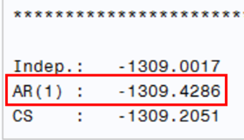

*\*\*\*\*\*\*\*\*\*\*\*\*\*\*\*\* IV. backward selection with AR(1) \*\*\*\*\*\*\*\*\*\*\*\*\*\*\*\*\*\*\*\*\*\*\*\*\*\*\*\*\*\*\**

*\* 1) AR(1);*

**proc** **genmod** data=uniseizure;

class id trt visit;

**model** cnt= trt|visit log_age|trt|visit log_base|trt|visit /link=log type3 d=poisson scale=p;

repeated subject=id(trt) / type=ar(**1**) within=visit;

ods output GEEFitCriteria=out2;

**run**;

**proc** **sql**;

select value into :q1

from out2

where criterion='QICu';

**quit**;

*\* 2) no three-way interaction;*

*\*\* Note. A|B|C @2 = A B C A*B A*C B*C, i.e. up to 2-way interactions;*

**proc** **genmod** data=uniseizure;

class id trt visit;

**model** cnt= trt|visit log_age|trt|visit log_base|trt|visit @**2** /link=log type3 d=poisson scale=p;

repeated subject=id(trt) / type=ar(**1**) within=visit;

ods output GEEFitCriteria=out2;

**run**;

**proc** **sql**;

select value into :q2

from out2

where criterion='QICu';

**quit**;

*\* 3) elliminate log_base*visit;*

**proc** **genmod** data=uniseizure;

class id trt visit;

**model** cnt= trt|visit log_age|trt log_age|visit log_base|trt /link=log type3 d=poisson scale=p;

repeated subject=id(trt) / type=ar(**1**) within=visit;

ods output GEEFitCriteria=out2;

**run**;

**proc** **sql**;

select value into :q3

from out2

where criterion='QICu';

**quit**;

*\* 4) elliminate log_base*trt;*

**proc** **genmod** data=uniseizure;

class id trt visit;

**model** cnt= trt|visit log_age|trt log_age|visit log_base|visit /link=log type3 d=poisson scale=p;

repeated subject=id(trt) / type=ar(**1**) within=visit;

ods output GEEFitCriteria=out2;

**run**;

**proc** **sql**;

select value into :q4

from out2

where criterion='QICu';

**quit**;

*\* 5) elliminate log_age*visit ;*

**proc** **genmod** data=uniseizure;

class id trt visit;

**model** cnt= trt|visit log_age|trt log_base|trt log_base|visit /link=log type3 d=poisson scale=p;

repeated subject=id(trt) / type=ar(**1**) within=visit;

ods output GEEFitCriteria=out2;

**run**;

**proc** **sql**;

select value into :q5

from out2

where criterion='QICu';

**quit**;

*\* 6) elliminate log_age*trt ;*

**proc** **genmod** data=uniseizure;

class id trt visit;

**model** cnt= trt|visit log_age|visit log_base|trt log_base|visit /link=log type3 d=poisson scale=p;

repeated subject=id(trt) / type=ar(**1**) within=visit;

ods output GEEFitCriteria=out2;

**run**;

**proc** **sql**;

select value into :q6

from out2

where criterion='QICu';

**quit**;

*\* 7) elliminate ..*visit ;*

**proc** **genmod** data=uniseizure;

class id trt visit;

**model** cnt= trt|visit log_age|trt log_base|trt /link=log type3 d=poisson scale=p;

repeated subject=id(trt) / type=ar(**1**) within=visit;

ods output GEEFitCriteria=out2;

**run**;

**proc** **sql**;

select value into :q7

from out2

where criterion='QICu';

**quit**;

*\* 8) elliminate ..*trt ;*

**proc** **genmod** data=uniseizure;

class id trt visit;

**model** cnt= trt|visit log_age|visit log_base|visit /link=log type3 d=poisson scale=p;

repeated subject=id(trt) / type=ar(**1**) within=visit;

ods output GEEFitCriteria=out2;

**run**;

**proc** **sql**;

select value into :q8

from out2

where criterion='QICu';

**quit**;

*\* 9) elliminate age*trt, base*visit ;*

**proc** **genmod** data=uniseizure;

class id trt visit;

**model** cnt= trt|visit log_age|visit log_base|trt /link=log type3 d=poisson scale=p;

repeated subject=id(trt) / type=ar(**1**) within=visit;

ods output GEEFitCriteria=out2;

**run**;

**proc** **sql**;

select value into :q9

from out2

where criterion='QICu';

**quit**;

*\* 10) elliminate age*visit, base*trt ;*

**proc** **genmod** data=uniseizure;

class id trt visit;

**model** cnt= trt|visit log_age|trt log_base|visit /link=log type3 d=poisson scale=p;

repeated subject=id(trt) / type=ar(**1**) within=visit;

ods output GEEFitCriteria=out2;

**run**;

**proc** **sql**;

select value into :q10

from out2

where criterion='QICu';

**quit**;

*\* 11) w/o age*.. base*..;*

**proc** **genmod** data=uniseizure;

class id trt visit;

**model** cnt= trt|visit log_age log_base /link=log type3 d=poisson scale=p;

repeated subject=id(trt) / type=ar(**1**) within=visit;

ods output GEEFitCriteria=out2; *create output **data** sets;

**run**;

**proc** **sql**;

select value into :q11

from out2

where criterion='QICu';

**quit**;

*\* 12) w/o trt*visit;*

**proc** **genmod** data=uniseizure;

class id trt visit;

**model** cnt= trt visit log_age|trt log_age|visit log_base|trt log_base|visit /link=log type3 d=poisson scale=p;

repeated subject=id(trt) / type=ar(**1**) within=visit;

ods output GEEFitCriteria=out2; *create output **data** sets;

**run**;

**proc** **sql**;

select value into :q12

from out2

where criterion='QICu';

**quit**;

*\* 13)w/o trt*visit, w/o base*visit;*

**proc** **genmod** data=uniseizure;

class id trt visit;

**model** cnt= trt visit log_age|trt log_age|visit log_base|trt /link=log type3 d=poisson scale=p;

repeated subject=id(trt) / type=ar(**1**) within=visit;

ods output GEEFitCriteria=out2; *create output **data** sets;

**run**;

**proc** **sql**;

select value into :q13

from out2

where criterion='QICu';

**quit**;

*\* 14)w/o trt*visit, w/o base*trt;*

**proc** **genmod** data=uniseizure;

class id trt visit;

**model** cnt= trt visit log_age|trt log_age|visit log_base|visit /link=log type3 d=poisson scale=p;

repeated subject=id(trt) / type=ar(**1**) within=visit;

ods output GEEFitCriteria=out2; *create output **data** sets;

**run**;

**proc** **sql**;

select value into :q14

from out2

where criterion='QICu';

**quit**;

*\* 15)w/o trt*visit, w/o age*visit;*

**proc** **genmod** data=uniseizure;

class id trt visit;

**model** cnt= trt visit log_age|trt log_base|trt log_base|visit /link=log type3 d=poisson scale=p;

repeated subject=id(trt) / type=ar(**1**) within=visit;

ods output GEEFitCriteria=out2; *create output **data** sets;

**run**;

**proc** **sql**;

select value into :q15

from out2

where criterion='QICu';

**quit**;

*\* 16)w/o trt*visit, w/o age*trt;*

**proc** **genmod** data=uniseizure;

class id trt visit;

**model** cnt= trt visit log_age|visit log_base|trt log_base|visit /link=log type3 d=poisson scale=p;

repeated subject=id(trt) / type=ar(**1**) within=visit;

ods output GEEFitCriteria=out2; *create output **data** sets;

**run**;

**proc** **sql**;

select value into :q16

from out2

where criterion='QICu';

**quit**;

*\* 17)w/o trt*visit, w/o ..*visit;*

**proc** **genmod** data=uniseizure;

class id trt visit;

**model** cnt= trt visit log_age|trt log_base|trt /link=log type3 d=poisson scale=p;

repeated subject=id(trt) / type=ar(**1**) within=visit;

ods output GEEFitCriteria=out2; *create output **data** sets;

**run**;

**proc** **sql**;

select value into :q17

from out2

where criterion='QICu';

**quit**;

*\* 18)w/o trt*visit, w/o age*visit w/o base*trt;*

**proc** **genmod** data=uniseizure;

class id trt visit;

**model** cnt= trt visit log_age|trt log_base|visit /link=log type3 d=poisson scale=p;

repeated subject=id(trt) / type=ar(**1**) within=visit;

ods output GEEFitCriteria=out2; *create output **data** sets;

**run**;

**proc** **sql**;

select value into :q18

from out2

where criterion='QICu';

**quit**;

*\* 19)w/o trt*visit, w/o age*trt w/o base*visit;*

**proc** **genmod** data=uniseizure;

class id trt visit;

**model** cnt= trt visit log_age|visit log_base|trt /link=log type3 d=poisson scale=p;

repeated subject=id(trt) / type=ar(**1**) within=visit;

ods output GEEFitCriteria=out2; *create output **data** sets;

**run**;

**proc** **sql**;

select value into :q19

from out2

where criterion='QICu';

**quit**;

*\* 20)w/o trt*visit, w/o ..*trt;*

**proc** **genmod** data=uniseizure;

class id trt visit;

**model** cnt= trt visit log_age|visit log_base|visit /link=log type3 d=poisson scale=p;

repeated subject=id(trt) / type=ar(**1**) within=visit;

ods output GEEFitCriteria=out2; *create output **data** sets;

**run**;

**proc** **sql**;

select value into :q20

from out2

where criterion='QICu';

**quit**;

*\* 21)w/o interactions;*

**proc** **genmod** data=uniseizure;

class id trt visit;

**model** cnt= trt visit log_age log_base /link=log type3 d=poisson scale=p;

repeated subject=id(trt) / type=ar(**1**) within=visit;

ods output GEEFitCriteria=out2; *create output **data** sets;

**run**;

**proc** **sql**;

select value into :q21

from out2

where criterion='QICu';

**quit**;

*\*\*\*\*\*\*\*\*\*\*\*\*\*\*\*\* V. Compare the QICu for the above models;*

**data** _null_;

file **print**;

put "mean1(full): &q1";

put "mean2(no 3-int): &q2";

put "mean3(w/o log_base*visit): &q3";

put "mean4(w/o log_base*trt): &q4";

put "mean5(w/o log_age*visit): &q5";

put "mean6(w/o log_age*trt): &q6";

put "mean7(w/o ..*visit): &q7";

put "mean8(w/o ..*trt): &q8";

put "mean9(w/o age*trt, base*visit): &q9";

put "mean10(w/o age*visit, base*trt): &q10";

put "mean11(no 2-int): &q11";

put "mean12(w/o trt*visit): &q12";

put "mean13(mean12 w/o base*visit): &q13";

put "mean14(mean12 w/o base*trt): &q14";

put "mean15(mean12 w/o age*visit): &q15";

put "mean16(mean12 w/o age*trt): &q16";

put "mean17(mean12 w/o ..*visit): &q17";

put "mean18(mean15 w/o base*trt): &q18";

put "mean19(mean16 w/o base*visit): &q19";

put "mean20(mean12 w/o ..*trt): &q20";

put "mean21(w/o): &q21";

**run**;

*\*\*\*\*\*\*\*\*\*\*\*\*\*\*\*\* VI. analyze the data with Model 16 ***************;*

*\* 16) model 16: w/o trt*visit, w/o age*trt;*

**proc** **genmod** data=uniseizure;

class id trt visit;

**model** cnt= trt visit log_age|visit log_base|trt log_base|visit /link=log type3 d=poisson scale=p;

repeated subject=id(trt) / type=ar(**1**) within=visit corrw;

ods output GEEFitCriteria=out2; *create output **data** sets;

**run**;

*\*\*\*\*\*\*\*\*\*\*\*\*\*\*\*\* VII. study trt difference ***************;*

**proc** **sql**;

select avg(log_base) into :mlb

from uniseizure;

**quit**;

ods trace on;

**proc** **genmod** data=uniseizure;

class id trt visit;

**model** cnt= trt visit log_age|visit log_base|trt log_base|visit /link=log type3 d=poisson scale=p;

repeated subject=id(trt) / type=ar(**1**) within=visit corrw;

contrast 'trt-score' trt **1** **-1**; *treatment effect at logbase=0 with **score** method;

contrast 'trt-wald' trt **1** **-1** /wald; *treatment effect at logbase=0 with Wald method;

estimate 'trt-wald' trt **1** **-1** ; *estimates of treatment effect at logbase=0 with Wald method;

contrast 'trt-score at mean' trt **1** **-1** log_base*trt &mlb. - &mlb.; *score test at logbase=&mlb. (the mean of logbase);

contrast 'trt-wald at mean' trt **1** **-1** log_base*trt &mlb. - &mlb./wald; *at logbase=&mlb. (the mean of logbase);

estimate 'trt-wald at mean' trt **1** **-1** log_base*trt &mlb. - &mlb.;

ods select Estimates Contrasts;

**run**;

ods trace off;

*\* The Wald estimates suggest that the point estimate of mean ratio (mu_0/mu_1)=exp(L'beta) at mean logbase*

is **1**.**4433**;

**quit**;

Exp (0.3669)= 1.4433 🡺 ratio between two means

First line (trt-wald): treatment effect at logbase=0

2nd line (trt-wald at mean); treatment effect at logbase=&mlb

* The Wald estimates suggest that the point estimate of mean ratio (mu_0/mu_1)=exp(L'beta) at mean logbase

is 1.4433.

**The final model:**

ln(E[*cntijk*​]) = *γ* + *τj*​ + *ρk* ​+ (*β*0 ​* log_base) + (*β*1​ * log_age) + (*β*2​ * log_base * *τj*​) + (*β*3​ * log_base * visit*k*​) + (*β*4 ​* log_age * visit*k*​)

Alternatively,

ln(*E*[*Yijk*​]) = *γ* + *τj* ​+ *ρk*​ + *β*0​ln(*xi*​) + *β*1​ln(age*i*​) + *β*2*j*​\**τj\**​ln(*xi*​) + *β*3*k\**​*ρk\**​ln(*xi*​) + *β*4*k\**​*ρk\**​ln(age*i*​)

where:

* *γ* : the overall intercept.
* *τj*​ : the effect of the treatment *j* (where *j*=0 for placebo, *j*=1 for Progabide).
* *ρk*​ : the effect of the *k*-th visit.
* *xi*​ : (the seizure count in the baseline period) / 4, for the *i*-th patient.
* *β*0​ : the coefficient for the main effect of the log-baseline seizure count.
* *β*1​ : the coefficient for the main effect of log-age.
* *β*2*j*​ : the coefficient for the interaction between treatment (j) and log-baseline seizure count.
* *β*3*k*​ : the coefficient for the interaction between visit (k) and log-baseline seizure count.
* *β*4*k*​ : the coefficient for the interaction between visit (k) and log-age.

**Results analysis:**

1. **Treatment Effect**: The result show that the test for H0: τ0=τ1 showed that with a p-value of 0.0093, there is a significant treatment effect of treatment on the response (seizure counts).
2. **Age Effects**: The age of patients (log_age) were found to be significant (p = 0.066), suggesting variability in seizure counts across different ages and visit periods.
3. **Baseline Seizure Count**: The log-baseline seizure count (log_base, p=0.0072) and its interaction with treatment (log_base*trt, p=0.0441) were significant, indicating the importance of the initial severity of the condition in the response to treatment.
4. **Treatment Efficacy**: The log odds of seizure counts for patients on placebo is 0.3669 units higher than for those on the Progabide, on the logarithmic scale. Wald tests conducted at mean logbase levels suggest the point estimate of the mean ratio (µ₀/µ₁) = Exp{L^T B.hat} = exp(β₁), the ratio of seizure counts between the placebo and treatment groups, is e^ 0.3669 = 1.4433 (p = 0.0337). This indicates that the mean seizure counts in the placebo group is 1.443 times that of the treatment group assuming all other variables are held constant. Thus, the results imply that treatment with Progabide has a substantial effect on reducing the frequency of seizures in patients with epilepsy.
5. **Contrast results**: Since there is interaction effect, “at mean" contrasts are used to estimate the effect of a treatment at the average value of log-base. The results indicates the significant effect of treatment at the mean level of log_base in the model. Thus, there is a statistically significant difference between treatment levels and this effect remains significant even when considering the average levels of log_base in this model.

**Conclusions**

The statistical evidence supports the efficacy of Progabide in reducing seizure frequency compared to placebo, with age and baseline seizure counts being important modifiers of this effect. The chosen GEE model with an AR(1) correlation structure provides a reliable understanding of treatment response profiles over time, accounting for repeated measures within subjects.